|  |  |
| --- | --- |
| 년도-학기 | 2021년 2학기 |
| 과목명 | 자동화프로그래밍 |

|  |  |
| --- | --- |
| **번호** | **실험 제목** |
| LAB 6 | State Feedback Controller |

|  |  |
| --- | --- |
| 실험 일자 | 2021년 10월 19일 |
| 제출자 이름 | 강** |
| 제출자 학번 | 201803**** |
| 팀원 이름 |  |
|  |  |

**Chapter 1. 관련 이론(Theoretical Background)**

<Full-state Feedback>

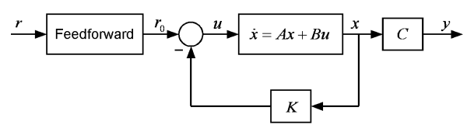

Full-state Feedback controller는 시스템의 상태방정식이 $\dot{x}=Ax+Bu$ 일 때 상태변수인 모든 x를 제어입력 u에 반영하여 피드백 하는 것을 의미한다.

따라서 $u=r_{0}-Kx$ 가 되고, 가 된다.

일 때 이고 이다.

따라서 로 나타낼 수 있다.

K는 정수로 이루어진 (1xn) 벡터이고 K 값에 따라 state feedback의 성능을 결정한다. K를 구하기 위해선 Ackermann’s formula 를 이용한다.

$K = \left[0 … 0 1\right]{M_{c}}^{-1}α_{c}(A)$ 식으로 구할 수 있고, $M_{c}=[B AB A^{2}B⋯A^{n-1}B]$, $α_{c}\left(A\right)={A^{n}+α}_{n-1}A^{n-1}+⋯+α_{1}A+α_{0}I$ 으로 나타낸다.

**Chapter 2. 실험 결과(Experimental Results)**

[Exercise 1]

$G\left(s\right)=\frac{10}{s\left(0.1s+1\right)}$ 일 때 Kp=1.0, Kd=0인 P제어기를 실행한 결과는 다음과 같다. 약간의 오버슛이 생기지만 1에 수렴한다.

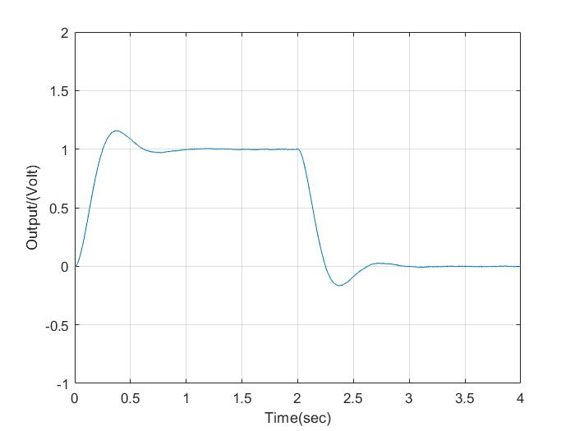

또한, SW1의 1번 스위치를 OFF하여 $G\left(s\right)=\frac{100}{s^{2}}$ 일 때 응답을 확인해본 결과는 다음과 같았다. 모든 pole이 허수축에 존재하여 시스템이 진동하는 것을 볼 수 있다.

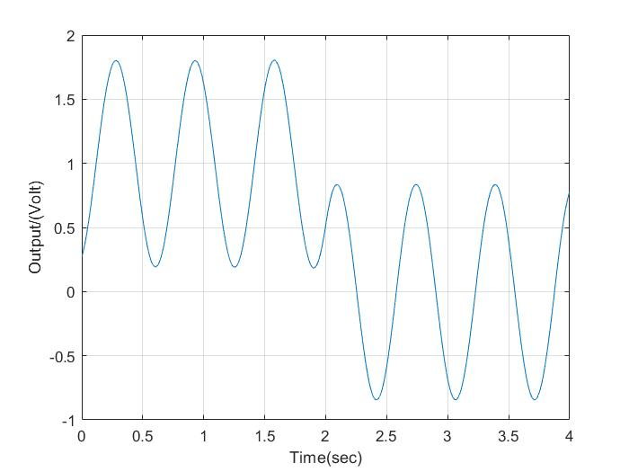

[Exercise 2]

SW1의 1번 스위치를 OFF한 상태에서 full-state feedback controller를 구현하는 실험을 수행하였다. $G\left(s\right)=\frac{100}{s^{2}}$ 이고, 다음 두 가지 경우로 pole을 선택하였다.

(1) 허수축에 가깝고, 실수축에선 먼 경우

이 때의 pole은 -5+j*15, -5-j*15 로 설정하였고 K1 = 2.5, k2 = -1 이 나왔다.

시뮬레이션 결과는 다음과 같다. Underdamped 상태이고 오버슛이 존재하지만 속도가 빠르다.

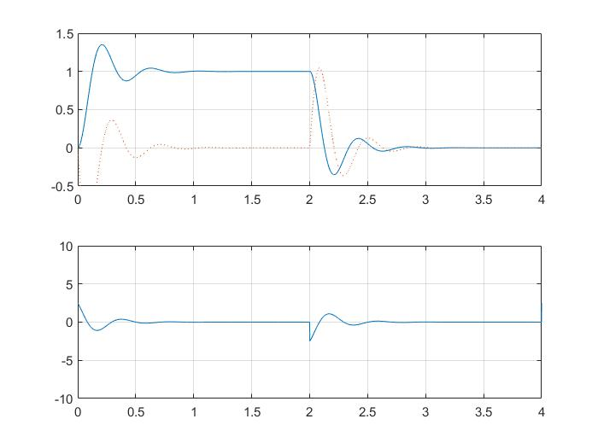  
설계한 제어기를 이용해 실행한 결과를 plot 해 본 결과는 다음과 같다.

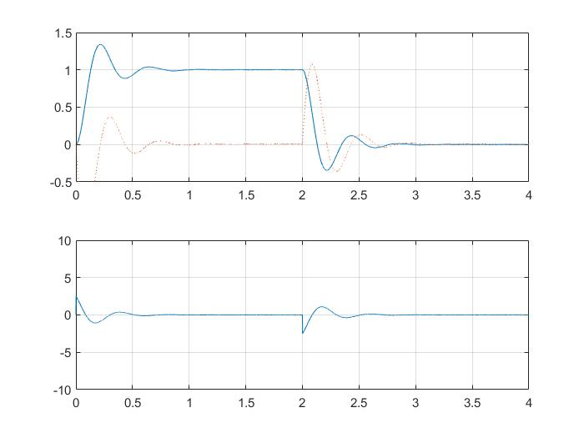

시뮬레이션과 실험결과가 같음을 볼 수 있다.

(2) 허수축에서 멀고, 실수축에 가까운 경우

이 때의 pole은 -15+j*5, -15-j*5 로 설정하였고 K1 = 2.5, k2 = -3 이 나왔다.

시뮬레이션 결과는 다음과 같다. Overdamped 상황으로 오버슛이 존재하지 않지만 속도가 느리다.

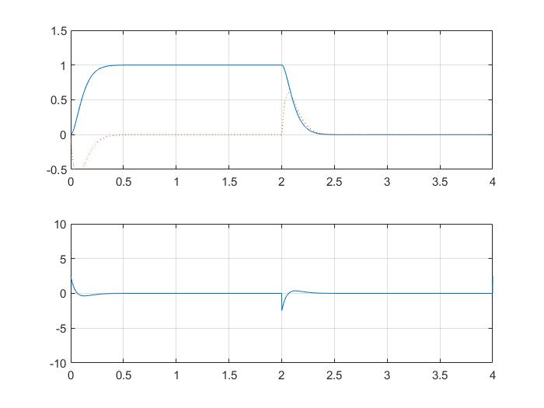

설계한 제어기를 이용해 실행한 결과를 plot 해 본 결과는 다음과 같다.

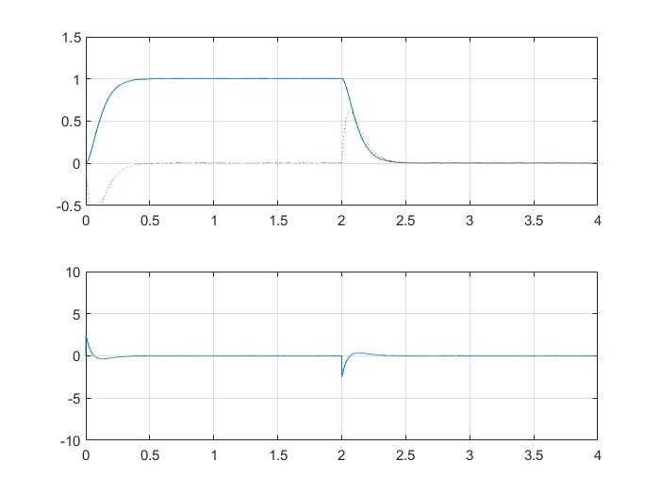

시뮬레이션과 실험결과가 같음을 볼 수 있다.

**Chapter 3. 결론 및 Discussion**

이번 실습은 특별히 어려운 점은 없었다. 원하는 pole의 위치를 정하면 그 특성에 맞는 따른 결과가 나타났다. 시뮬레이션 결과와 실험 결과를 비교해보았을 때도 일치하였다. Pole이 허수축에 가깝고, 실수축에선 먼 경우엔 damping ratio와 wn이 작아 오버슛이 크고 속도가 느리지만, pole이 허수축에서 멀고, 실수축에 가까운 경우에는 damping raio와 wn이 커서 오버슛이 작거나 없고, 속도가 빠른 것을 볼 수 있었다.

이번 실습은 이전 실습과 달리 원하는 pole의 위치를 먼저 정하고 이에 따라 제어기를 설계할 수 있다는 점에서 가장 달랐다. 이로 인해 원하는 제어 특성을 가지는 제어기를 설계할 수 있다는 장점을 가지는 것 같다. 하지만 실제로는 모든 변수를 피드백 한다는 것이 측정 자체가 불가능할 수 있다는 근본적 문제와 실용적이지 않고 비경제적이라는 문제로 state feedback을 잘 사용하지 않는다고 한다.

**Appendix:**

**K 값에 대해서만 수정이 필요했기 때문에 별도 파일은 첨부하지 않았습니다.**

**아래는 Exercise 2 (1)의 코드입니다.**

/* USER CODE BEGIN Header */

/**

******************************************************************************

* @file : main.c

* @brief : Main program body

******************************************************************************

* @attention

*

* <h2><center>&copy; Copyright (c) 2021 STMicroelectronics.

* All rights reserved.</center></h2>

*

* This software component is licensed by ST under Ultimate Liberty license

* SLA0044, the "License"; You may not use this file except in compliance with

* the License. You may obtain a copy of the License at:

* www.st.com/SLA0044

*

******************************************************************************

*/

/* USER CODE END Header */

/* Includes ------------------------------------------------------------------*/

#include "main.h"

#include "usb_host.h"

/* Private includes ----------------------------------------------------------*/

/* USER CODE BEGIN Includes */

#include "stdio.h"

/* USER CODE END Includes */

/* Private typedef -----------------------------------------------------------*/

/* USER CODE BEGIN PTD */

/* USER CODE END PTD */

/* Private define ------------------------------------------------------------*/

/* USER CODE BEGIN PD */

/* USER CODE END PD */

/* Private macro -------------------------------------------------------------*/

/* USER CODE BEGIN PM */

/* USER CODE END PM */

/* Private variables ---------------------------------------------------------*/

ADC_HandleTypeDef hadc1;

ADC_HandleTypeDef hadc3;

CRC_HandleTypeDef hcrc;

DAC_HandleTypeDef hdac;

DMA2D_HandleTypeDef hdma2d;

I2C_HandleTypeDef hi2c3;

LTDC_HandleTypeDef hltdc;

SPI_HandleTypeDef hspi5;

TIM_HandleTypeDef htim1;

TIM_HandleTypeDef htim10;

UART_HandleTypeDef huart1;

SDRAM_HandleTypeDef hsdram1;

/* USER CODE BEGIN PV */

float K1,K2,control;

volatile int32_t x1,x2,ref,interrupt_counter,sampling_frequency,data_counter;

int16_t data[4000],data2[4000],data3[4000];

volatile uint8_t data_flag=0,data_done=0;

/* USER CODE END PV */

/* Private function prototypes -----------------------------------------------*/

void SystemClock_Config(void);

static void MX_GPIO_Init(void);

static void MX_CRC_Init(void);

static void MX_DMA2D_Init(void);

static void MX_FMC_Init(void);

static void MX_I2C3_Init(void);

static void MX_LTDC_Init(void);

static void MX_SPI5_Init(void);

static void MX_TIM1_Init(void);

static void MX_USART1_UART_Init(void);

static void MX_ADC1_Init(void);

static void MX_ADC3_Init(void);

static void MX_DAC_Init(void);

static void MX_TIM10_Init(void);

void MX_USB_HOST_Process(void);

/* USER CODE BEGIN PFP */

/* USER CODE END PFP */

/* Private user code ---------------------------------------------------------*/

/* USER CODE BEGIN 0 */

#ifdef __GNUC__

#define PUTCHAR_PROTOTYPE int __io_putchar(int ch)

#else

#define PUTCHAR_PROTOTYPE int fputc(int ch, FILE *f)

#endif /* __GNUC__ */

PUTCHAR_PROTOTYPE

{

HAL_UART_Transmit(&huart1, (uint8_t *)&ch, 1, 0xFFFF);

return ch;

}

/* USER CODE END 0 */

/**

* @brief The application entry point.

* @retval int

*/

int main(void)

{

/* USER CODE BEGIN 1 */

K1=2.5;K2=-1.0;

sampling_frequency=1000;

/* USER CODE END 1 */

/* MCU Configuration--------------------------------------------------------*/

/* Reset of all peripherals, Initializes the Flash interface and the Systick. */

HAL_Init();

/* USER CODE BEGIN Init */

/* USER CODE END Init */

/* Configure the system clock */

SystemClock_Config();

/* USER CODE BEGIN SysInit */

/* USER CODE END SysInit */

/* Initialize all configured peripherals */

MX_GPIO_Init();

MX_CRC_Init();

MX_DMA2D_Init();

MX_FMC_Init();

MX_I2C3_Init();

MX_LTDC_Init();

MX_SPI5_Init();

MX_TIM1_Init();

MX_USART1_UART_Init();

MX_USB_HOST_Init();

MX_ADC1_Init();

MX_ADC3_Init();

MX_DAC_Init();

MX_TIM10_Init();

/* USER CODE BEGIN 2 */

HAL_TIM_Base_Start_IT(&htim10);

HAL_DAC_Start(&hdac, DAC_CHANNEL_2);

/* USER CODE END 2 */

/* Infinite loop */

/* USER CODE BEGIN WHILE */

while (1)

{

if(data_done == 1) {

for (int i=0; i < sampling_frequency*4 ;i++){

printf("%d %d %d %d\r\n",i,data[i],data2[i],data3[i]);

}

data_flag=0;

data_done=0;

HAL_GPIO_TogglePin(GPIOG, GPIO_PIN_14);

}

/* USER CODE END WHILE */

MX_USB_HOST_Process();

/* USER CODE BEGIN 3 */

}

/* USER CODE END 3 */

}

/**

* @brief System Clock Configuration

* @retval None

*/

void SystemClock_Config(void)

{

RCC_OscInitTypeDef RCC_OscInitStruct = {0};

RCC_ClkInitTypeDef RCC_ClkInitStruct = {0};

/** Configure the main internal regulator output voltage

*/

__HAL_RCC_PWR_CLK_ENABLE();

__HAL_PWR_VOLTAGESCALING_CONFIG(PWR_REGULATOR_VOLTAGE_SCALE1);

/** Initializes the RCC Oscillators according to the specified parameters

* in the RCC_OscInitTypeDef structure.

*/

RCC_OscInitStruct.OscillatorType = RCC_OSCILLATORTYPE_HSE;

RCC_OscInitStruct.HSEState = RCC_HSE_ON;

RCC_OscInitStruct.PLL.PLLState = RCC_PLL_ON;

RCC_OscInitStruct.PLL.PLLSource = RCC_PLLSOURCE_HSE;

RCC_OscInitStruct.PLL.PLLM = 4;

RCC_OscInitStruct.PLL.PLLN = 168;

RCC_OscInitStruct.PLL.PLLP = RCC_PLLP_DIV2;

RCC_OscInitStruct.PLL.PLLQ = 7;

if (HAL_RCC_OscConfig(&RCC_OscInitStruct) != HAL_OK)

{

Error_Handler();

}

/** Initializes the CPU, AHB and APB buses clocks

*/

RCC_ClkInitStruct.ClockType = RCC_CLOCKTYPE_HCLK|RCC_CLOCKTYPE_SYSCLK

|RCC_CLOCKTYPE_PCLK1|RCC_CLOCKTYPE_PCLK2;

RCC_ClkInitStruct.SYSCLKSource = RCC_SYSCLKSOURCE_PLLCLK;

RCC_ClkInitStruct.AHBCLKDivider = RCC_SYSCLK_DIV1;

RCC_ClkInitStruct.APB1CLKDivider = RCC_HCLK_DIV4;

RCC_ClkInitStruct.APB2CLKDivider = RCC_HCLK_DIV2;

if (HAL_RCC_ClockConfig(&RCC_ClkInitStruct, FLASH_LATENCY_5) != HAL_OK)

{

Error_Handler();

}

}

/**

* @brief ADC1 Initialization Function

* @param None

* @retval None

*/

static void MX_ADC1_Init(void)

{

/* USER CODE BEGIN ADC1_Init 0 */

/* USER CODE END ADC1_Init 0 */

ADC_ChannelConfTypeDef sConfig = {0};

/* USER CODE BEGIN ADC1_Init 1 */

/* USER CODE END ADC1_Init 1 */

/** Configure the global features of the ADC (Clock, Resolution, Data Alignment and number of conversion)

*/

hadc1.Instance = ADC1;

hadc1.Init.ClockPrescaler = ADC_CLOCK_SYNC_PCLK_DIV4;

hadc1.Init.Resolution = ADC_RESOLUTION_12B;

hadc1.Init.ScanConvMode = DISABLE;

hadc1.Init.ContinuousConvMode = DISABLE;

hadc1.Init.DiscontinuousConvMode = DISABLE;

hadc1.Init.ExternalTrigConvEdge = ADC_EXTERNALTRIGCONVEDGE_NONE;

hadc1.Init.ExternalTrigConv = ADC_SOFTWARE_START;

hadc1.Init.DataAlign = ADC_DATAALIGN_RIGHT;

hadc1.Init.NbrOfConversion = 1;

hadc1.Init.DMAContinuousRequests = DISABLE;

hadc1.Init.EOCSelection = ADC_EOC_SINGLE_CONV;

if (HAL_ADC_Init(&hadc1) != HAL_OK)

{

Error_Handler();

}

/** Configure for the selected ADC regular channel its corresponding rank in the sequencer and its sample time.

*/

sConfig.Channel = ADC_CHANNEL_13;

sConfig.Rank = 1;

sConfig.SamplingTime = ADC_SAMPLETIME_3CYCLES;

if (HAL_ADC_ConfigChannel(&hadc1, &sConfig) != HAL_OK)

{

Error_Handler();

}

/* USER CODE BEGIN ADC1_Init 2 */

/* USER CODE END ADC1_Init 2 */

}

/**

* @brief ADC3 Initialization Function

* @param None

* @retval None

*/

static void MX_ADC3_Init(void)

{

/* USER CODE BEGIN ADC3_Init 0 */

/* USER CODE END ADC3_Init 0 */

ADC_ChannelConfTypeDef sConfig = {0};

/* USER CODE BEGIN ADC3_Init 1 */

/* USER CODE END ADC3_Init 1 */

/** Configure the global features of the ADC (Clock, Resolution, Data Alignment and number of conversion)

*/

hadc3.Instance = ADC3;

hadc3.Init.ClockPrescaler = ADC_CLOCK_SYNC_PCLK_DIV4;

hadc3.Init.Resolution = ADC_RESOLUTION_12B;

hadc3.Init.ScanConvMode = DISABLE;

hadc3.Init.ContinuousConvMode = DISABLE;

hadc3.Init.DiscontinuousConvMode = DISABLE;

hadc3.Init.ExternalTrigConvEdge = ADC_EXTERNALTRIGCONVEDGE_NONE;

hadc3.Init.ExternalTrigConv = ADC_SOFTWARE_START;

hadc3.Init.DataAlign = ADC_DATAALIGN_RIGHT;

hadc3.Init.NbrOfConversion = 1;

hadc3.Init.DMAContinuousRequests = DISABLE;

hadc3.Init.EOCSelection = ADC_EOC_SINGLE_CONV;

if (HAL_ADC_Init(&hadc3) != HAL_OK)

{

Error_Handler();

}

/** Configure for the selected ADC regular channel its corresponding rank in the sequencer and its sample time.

*/

sConfig.Channel = ADC_CHANNEL_4;

sConfig.Rank = 1;

sConfig.SamplingTime = ADC_SAMPLETIME_3CYCLES;

if (HAL_ADC_ConfigChannel(&hadc3, &sConfig) != HAL_OK)

{

Error_Handler();

}

/* USER CODE BEGIN ADC3_Init 2 */

/* USER CODE END ADC3_Init 2 */

}

/**

* @brief CRC Initialization Function

* @param None

* @retval None

*/

static void MX_CRC_Init(void)

{

/* USER CODE BEGIN CRC_Init 0 */

/* USER CODE END CRC_Init 0 */

/* USER CODE BEGIN CRC_Init 1 */

/* USER CODE END CRC_Init 1 */

hcrc.Instance = CRC;

if (HAL_CRC_Init(&hcrc) != HAL_OK)

{

Error_Handler();

}

/* USER CODE BEGIN CRC_Init 2 */

/* USER CODE END CRC_Init 2 */

}

/**

* @brief DAC Initialization Function

* @param None

* @retval None

*/

static void MX_DAC_Init(void)

{

/* USER CODE BEGIN DAC_Init 0 */

/* USER CODE END DAC_Init 0 */

DAC_ChannelConfTypeDef sConfig = {0};

/* USER CODE BEGIN DAC_Init 1 */

/* USER CODE END DAC_Init 1 */

/** DAC Initialization

*/

hdac.Instance = DAC;

if (HAL_DAC_Init(&hdac) != HAL_OK)

{

Error_Handler();

}

/** DAC channel OUT2 config

*/

sConfig.DAC_Trigger = DAC_TRIGGER_NONE;

sConfig.DAC_OutputBuffer = DAC_OUTPUTBUFFER_ENABLE;

if (HAL_DAC_ConfigChannel(&hdac, &sConfig, DAC_CHANNEL_2) != HAL_OK)

{

Error_Handler();

}

/* USER CODE BEGIN DAC_Init 2 */

/* USER CODE END DAC_Init 2 */

}

/**

* @brief DMA2D Initialization Function

* @param None

* @retval None

*/

static void MX_DMA2D_Init(void)

{

/* USER CODE BEGIN DMA2D_Init 0 */

/* USER CODE END DMA2D_Init 0 */

/* USER CODE BEGIN DMA2D_Init 1 */

/* USER CODE END DMA2D_Init 1 */

hdma2d.Instance = DMA2D;

hdma2d.Init.Mode = DMA2D_M2M;

hdma2d.Init.ColorMode = DMA2D_OUTPUT_ARGB8888;

hdma2d.Init.OutputOffset = 0;

hdma2d.LayerCfg[1].InputOffset = 0;

hdma2d.LayerCfg[1].InputColorMode = DMA2D_INPUT_ARGB8888;

hdma2d.LayerCfg[1].AlphaMode = DMA2D_NO_MODIF_ALPHA;

hdma2d.LayerCfg[1].InputAlpha = 0;

if (HAL_DMA2D_Init(&hdma2d) != HAL_OK)

{

Error_Handler();

}

if (HAL_DMA2D_ConfigLayer(&hdma2d, 1) != HAL_OK)

{

Error_Handler();

}

/* USER CODE BEGIN DMA2D_Init 2 */

/* USER CODE END DMA2D_Init 2 */

}

/**

* @brief I2C3 Initialization Function

* @param None

* @retval None

*/

static void MX_I2C3_Init(void)

{

/* USER CODE BEGIN I2C3_Init 0 */

/* USER CODE END I2C3_Init 0 */

/* USER CODE BEGIN I2C3_Init 1 */

/* USER CODE END I2C3_Init 1 */

hi2c3.Instance = I2C3;

hi2c3.Init.ClockSpeed = 100000;

hi2c3.Init.DutyCycle = I2C_DUTYCYCLE_2;

hi2c3.Init.OwnAddress1 = 0;

hi2c3.Init.AddressingMode = I2C_ADDRESSINGMODE_7BIT;

hi2c3.Init.DualAddressMode = I2C_DUALADDRESS_DISABLE;

hi2c3.Init.OwnAddress2 = 0;

hi2c3.Init.GeneralCallMode = I2C_GENERALCALL_DISABLE;

hi2c3.Init.NoStretchMode = I2C_NOSTRETCH_DISABLE;

if (HAL_I2C_Init(&hi2c3) != HAL_OK)

{

Error_Handler();

}

/** Configure Analogue filter

*/

if (HAL_I2CEx_ConfigAnalogFilter(&hi2c3, I2C_ANALOGFILTER_ENABLE) != HAL_OK)

{

Error_Handler();

}

/** Configure Digital filter

*/

if (HAL_I2CEx_ConfigDigitalFilter(&hi2c3, 0) != HAL_OK)

{

Error_Handler();

}

/* USER CODE BEGIN I2C3_Init 2 */

/* USER CODE END I2C3_Init 2 */

}

/**

* @brief LTDC Initialization Function

* @param None

* @retval None

*/

static void MX_LTDC_Init(void)

{

/* USER CODE BEGIN LTDC_Init 0 */

/* USER CODE END LTDC_Init 0 */

LTDC_LayerCfgTypeDef pLayerCfg = {0};

/* USER CODE BEGIN LTDC_Init 1 */

/* USER CODE END LTDC_Init 1 */

hltdc.Instance = LTDC;

hltdc.Init.HSPolarity = LTDC_HSPOLARITY_AL;

hltdc.Init.VSPolarity = LTDC_VSPOLARITY_AL;

hltdc.Init.DEPolarity = LTDC_DEPOLARITY_AL;

hltdc.Init.PCPolarity = LTDC_PCPOLARITY_IPC;

hltdc.Init.HorizontalSync = 9;

hltdc.Init.VerticalSync = 1;

hltdc.Init.AccumulatedHBP = 29;

hltdc.Init.AccumulatedVBP = 3;

hltdc.Init.AccumulatedActiveW = 269;

hltdc.Init.AccumulatedActiveH = 323;

hltdc.Init.TotalWidth = 279;

hltdc.Init.TotalHeigh = 327;

hltdc.Init.Backcolor.Blue = 0;

hltdc.Init.Backcolor.Green = 0;

hltdc.Init.Backcolor.Red = 0;

if (HAL_LTDC_Init(&hltdc) != HAL_OK)

{

Error_Handler();

}

pLayerCfg.WindowX0 = 0;

pLayerCfg.WindowX1 = 240;

pLayerCfg.WindowY0 = 0;

pLayerCfg.WindowY1 = 320;

pLayerCfg.PixelFormat = LTDC_PIXEL_FORMAT_RGB565;

pLayerCfg.Alpha = 255;

pLayerCfg.Alpha0 = 0;

pLayerCfg.BlendingFactor1 = LTDC_BLENDING_FACTOR1_PAxCA;

pLayerCfg.BlendingFactor2 = LTDC_BLENDING_FACTOR2_PAxCA;

pLayerCfg.FBStartAdress = 0xD0000000;

pLayerCfg.ImageWidth = 240;

pLayerCfg.ImageHeight = 320;

pLayerCfg.Backcolor.Blue = 0;

pLayerCfg.Backcolor.Green = 0;

pLayerCfg.Backcolor.Red = 0;

if (HAL_LTDC_ConfigLayer(&hltdc, &pLayerCfg, 0) != HAL_OK)

{

Error_Handler();

}

/* USER CODE BEGIN LTDC_Init 2 */

/* USER CODE END LTDC_Init 2 */

}

/**

* @brief SPI5 Initialization Function

* @param None

* @retval None

*/

static void MX_SPI5_Init(void)

{

/* USER CODE BEGIN SPI5_Init 0 */

/* USER CODE END SPI5_Init 0 */

/* USER CODE BEGIN SPI5_Init 1 */

/* USER CODE END SPI5_Init 1 */

/* SPI5 parameter configuration*/

hspi5.Instance = SPI5;

hspi5.Init.Mode = SPI_MODE_MASTER;

hspi5.Init.Direction = SPI_DIRECTION_2LINES;

hspi5.Init.DataSize = SPI_DATASIZE_8BIT;

hspi5.Init.CLKPolarity = SPI_POLARITY_LOW;

hspi5.Init.CLKPhase = SPI_PHASE_1EDGE;

hspi5.Init.NSS = SPI_NSS_SOFT;

hspi5.Init.BaudRatePrescaler = SPI_BAUDRATEPRESCALER_16;

hspi5.Init.FirstBit = SPI_FIRSTBIT_MSB;

hspi5.Init.TIMode = SPI_TIMODE_DISABLE;

hspi5.Init.CRCCalculation = SPI_CRCCALCULATION_DISABLE;

hspi5.Init.CRCPolynomial = 10;

if (HAL_SPI_Init(&hspi5) != HAL_OK)

{

Error_Handler();

}

/* USER CODE BEGIN SPI5_Init 2 */

/* USER CODE END SPI5_Init 2 */

}

/**

* @brief TIM1 Initialization Function

* @param None

* @retval None

*/

static void MX_TIM1_Init(void)

{

/* USER CODE BEGIN TIM1_Init 0 */

/* USER CODE END TIM1_Init 0 */

TIM_ClockConfigTypeDef sClockSourceConfig = {0};

TIM_MasterConfigTypeDef sMasterConfig = {0};

/* USER CODE BEGIN TIM1_Init 1 */

/* USER CODE END TIM1_Init 1 */

htim1.Instance = TIM1;

htim1.Init.Prescaler = 0;

htim1.Init.CounterMode = TIM_COUNTERMODE_UP;

htim1.Init.Period = 65535;

htim1.Init.ClockDivision = TIM_CLOCKDIVISION_DIV1;

htim1.Init.RepetitionCounter = 0;

htim1.Init.AutoReloadPreload = TIM_AUTORELOAD_PRELOAD_DISABLE;

if (HAL_TIM_Base_Init(&htim1) != HAL_OK)

{

Error_Handler();

}

sClockSourceConfig.ClockSource = TIM_CLOCKSOURCE_INTERNAL;

if (HAL_TIM_ConfigClockSource(&htim1, &sClockSourceConfig) != HAL_OK)

{

Error_Handler();

}

sMasterConfig.MasterOutputTrigger = TIM_TRGO_RESET;

sMasterConfig.MasterSlaveMode = TIM_MASTERSLAVEMODE_DISABLE;

if (HAL_TIMEx_MasterConfigSynchronization(&htim1, &sMasterConfig) != HAL_OK)

{

Error_Handler();

}

/* USER CODE BEGIN TIM1_Init 2 */

/* USER CODE END TIM1_Init 2 */

}

/**

* @brief TIM10 Initialization Function

* @param None

* @retval None

*/

static void MX_TIM10_Init(void)

{

/* USER CODE BEGIN TIM10_Init 0 */

/* USER CODE END TIM10_Init 0 */

/* USER CODE BEGIN TIM10_Init 1 */

/* USER CODE END TIM10_Init 1 */

htim10.Instance = TIM10;

htim10.Init.Prescaler = 839;

htim10.Init.CounterMode = TIM_COUNTERMODE_UP;

htim10.Init.Period = 199;

htim10.Init.ClockDivision = TIM_CLOCKDIVISION_DIV1;

htim10.Init.AutoReloadPreload = TIM_AUTORELOAD_PRELOAD_DISABLE;

if (HAL_TIM_Base_Init(&htim10) != HAL_OK)

{

Error_Handler();

}

/* USER CODE BEGIN TIM10_Init 2 */

/* USER CODE END TIM10_Init 2 */

}

/**

* @brief USART1 Initialization Function

* @param None

* @retval None

*/

static void MX_USART1_UART_Init(void)

{

/* USER CODE BEGIN USART1_Init 0 */

/* USER CODE END USART1_Init 0 */

/* USER CODE BEGIN USART1_Init 1 */

/* USER CODE END USART1_Init 1 */

huart1.Instance = USART1;

huart1.Init.BaudRate = 115200;

huart1.Init.WordLength = UART_WORDLENGTH_8B;

huart1.Init.StopBits = UART_STOPBITS_1;

huart1.Init.Parity = UART_PARITY_NONE;

huart1.Init.Mode = UART_MODE_TX_RX;

huart1.Init.HwFlowCtl = UART_HWCONTROL_NONE;

huart1.Init.OverSampling = UART_OVERSAMPLING_16;

if (HAL_UART_Init(&huart1) != HAL_OK)

{

Error_Handler();

}

/* USER CODE BEGIN USART1_Init 2 */

/* USER CODE END USART1_Init 2 */

}

/* FMC initialization function */

static void MX_FMC_Init(void)

{

/* USER CODE BEGIN FMC_Init 0 */

/* USER CODE END FMC_Init 0 */

FMC_SDRAM_TimingTypeDef SdramTiming = {0};

/* USER CODE BEGIN FMC_Init 1 */

/* USER CODE END FMC_Init 1 */

/** Perform the SDRAM1 memory initialization sequence

*/

hsdram1.Instance = FMC_SDRAM_DEVICE;

/* hsdram1.Init */

hsdram1.Init.SDBank = FMC_SDRAM_BANK2;

hsdram1.Init.ColumnBitsNumber = FMC_SDRAM_COLUMN_BITS_NUM_8;

hsdram1.Init.RowBitsNumber = FMC_SDRAM_ROW_BITS_NUM_12;

hsdram1.Init.MemoryDataWidth = FMC_SDRAM_MEM_BUS_WIDTH_16;

hsdram1.Init.InternalBankNumber = FMC_SDRAM_INTERN_BANKS_NUM_4;

hsdram1.Init.CASLatency = FMC_SDRAM_CAS_LATENCY_3;

hsdram1.Init.WriteProtection = FMC_SDRAM_WRITE_PROTECTION_DISABLE;

hsdram1.Init.SDClockPeriod = FMC_SDRAM_CLOCK_PERIOD_2;

hsdram1.Init.ReadBurst = FMC_SDRAM_RBURST_DISABLE;

hsdram1.Init.ReadPipeDelay = FMC_SDRAM_RPIPE_DELAY_1;

/* SdramTiming */

SdramTiming.LoadToActiveDelay = 2;

SdramTiming.ExitSelfRefreshDelay = 7;

SdramTiming.SelfRefreshTime = 4;

SdramTiming.RowCycleDelay = 7;

SdramTiming.WriteRecoveryTime = 3;

SdramTiming.RPDelay = 2;

SdramTiming.RCDDelay = 2;

if (HAL_SDRAM_Init(&hsdram1, &SdramTiming) != HAL_OK)

{

Error_Handler( );

}

/* USER CODE BEGIN FMC_Init 2 */

/* USER CODE END FMC_Init 2 */

}

/**

* @brief GPIO Initialization Function

* @param None

* @retval None

*/

static void MX_GPIO_Init(void)

{

GPIO_InitTypeDef GPIO_InitStruct = {0};

/* GPIO Ports Clock Enable */

__HAL_RCC_GPIOC_CLK_ENABLE();

__HAL_RCC_GPIOF_CLK_ENABLE();

__HAL_RCC_GPIOH_CLK_ENABLE();

__HAL_RCC_GPIOA_CLK_ENABLE();

__HAL_RCC_GPIOB_CLK_ENABLE();

__HAL_RCC_GPIOG_CLK_ENABLE();

__HAL_RCC_GPIOE_CLK_ENABLE();

__HAL_RCC_GPIOD_CLK_ENABLE();

/*Configure GPIO pin Output Level */

HAL_GPIO_WritePin(GPIOC, NCS_MEMS_SPI_Pin|CSX_Pin|OTG_FS_PSO_Pin, GPIO_PIN_RESET);

/*Configure GPIO pin Output Level */

HAL_GPIO_WritePin(ACP_RST_GPIO_Port, ACP_RST_Pin, GPIO_PIN_RESET);

/*Configure GPIO pin Output Level */

HAL_GPIO_WritePin(GPIOD, RDX_Pin|WRX_DCX_Pin, GPIO_PIN_RESET);

/*Configure GPIO pin Output Level */

HAL_GPIO_WritePin(GPIOG, LD3_Pin|LD4_Pin, GPIO_PIN_RESET);

/*Configure GPIO pins : NCS_MEMS_SPI_Pin CSX_Pin OTG_FS_PSO_Pin */

GPIO_InitStruct.Pin = NCS_MEMS_SPI_Pin|CSX_Pin|OTG_FS_PSO_Pin;

GPIO_InitStruct.Mode = GPIO_MODE_OUTPUT_PP;

GPIO_InitStruct.Pull = GPIO_NOPULL;

GPIO_InitStruct.Speed = GPIO_SPEED_FREQ_LOW;

HAL_GPIO_Init(GPIOC, &GPIO_InitStruct);

/*Configure GPIO pin : B1_Pin */

GPIO_InitStruct.Pin = B1_Pin;

GPIO_InitStruct.Mode = GPIO_MODE_IT_RISING;

GPIO_InitStruct.Pull = GPIO_NOPULL;

HAL_GPIO_Init(B1_GPIO_Port, &GPIO_InitStruct);

/*Configure GPIO pins : MEMS_INT1_Pin MEMS_INT2_Pin TP_INT1_Pin */

GPIO_InitStruct.Pin = MEMS_INT1_Pin|MEMS_INT2_Pin|TP_INT1_Pin;

GPIO_InitStruct.Mode = GPIO_MODE_EVT_RISING;

GPIO_InitStruct.Pull = GPIO_NOPULL;

HAL_GPIO_Init(GPIOA, &GPIO_InitStruct);

/*Configure GPIO pin : ACP_RST_Pin */

GPIO_InitStruct.Pin = ACP_RST_Pin;

GPIO_InitStruct.Mode = GPIO_MODE_OUTPUT_PP;

GPIO_InitStruct.Pull = GPIO_NOPULL;

GPIO_InitStruct.Speed = GPIO_SPEED_FREQ_LOW;

HAL_GPIO_Init(ACP_RST_GPIO_Port, &GPIO_InitStruct);

/*Configure GPIO pin : OTG_FS_OC_Pin */

GPIO_InitStruct.Pin = OTG_FS_OC_Pin;

GPIO_InitStruct.Mode = GPIO_MODE_EVT_RISING;

GPIO_InitStruct.Pull = GPIO_NOPULL;

HAL_GPIO_Init(OTG_FS_OC_GPIO_Port, &GPIO_InitStruct);

/*Configure GPIO pin : BOOT1_Pin */

GPIO_InitStruct.Pin = BOOT1_Pin;

GPIO_InitStruct.Mode = GPIO_MODE_INPUT;

GPIO_InitStruct.Pull = GPIO_NOPULL;

HAL_GPIO_Init(BOOT1_GPIO_Port, &GPIO_InitStruct);

/*Configure GPIO pin : TE_Pin */

GPIO_InitStruct.Pin = TE_Pin;

GPIO_InitStruct.Mode = GPIO_MODE_INPUT;

GPIO_InitStruct.Pull = GPIO_NOPULL;

HAL_GPIO_Init(TE_GPIO_Port, &GPIO_InitStruct);

/*Configure GPIO pins : RDX_Pin WRX_DCX_Pin */

GPIO_InitStruct.Pin = RDX_Pin|WRX_DCX_Pin;

GPIO_InitStruct.Mode = GPIO_MODE_OUTPUT_PP;

GPIO_InitStruct.Pull = GPIO_NOPULL;

GPIO_InitStruct.Speed = GPIO_SPEED_FREQ_LOW;

HAL_GPIO_Init(GPIOD, &GPIO_InitStruct);

/*Configure GPIO pins : LD3_Pin LD4_Pin */

GPIO_InitStruct.Pin = LD3_Pin|LD4_Pin;

GPIO_InitStruct.Mode = GPIO_MODE_OUTPUT_PP;

GPIO_InitStruct.Pull = GPIO_NOPULL;

GPIO_InitStruct.Speed = GPIO_SPEED_FREQ_LOW;

HAL_GPIO_Init(GPIOG, &GPIO_InitStruct);

/* EXTI interrupt init*/

HAL_NVIC_SetPriority(EXTI0_IRQn, 0, 0);

HAL_NVIC_EnableIRQ(EXTI0_IRQn);

}

/* USER CODE BEGIN 4 */

void HAL_GPIO_EXTI_Callback(uint16_t GPIO_Pin)

{

HAL_GPIO_WritePin(GPIOG, GPIO_PIN_14, GPIO_PIN_SET);

data_flag=1;

}

/* USER CODE END 4 */

/**

* @brief Period elapsed callback in non blocking mode

* @note This function is called when TIM6 interrupt took place, inside

* HAL_TIM_IRQHandler(). It makes a direct call to HAL_IncTick() to increment

* a global variable "uwTick" used as application time base.

* @param htim : TIM handle

* @retval None

*/

void HAL_TIM_PeriodElapsedCallback(TIM_HandleTypeDef *htim)

{

/* USER CODE BEGIN Callback 0 */

int32_t da_value,ad_value,sum;

if (htim->Instance == TIM10) {

sum=0;

for (int i=0; i<20 ; i++) {

HAL_ADC_Start(&hadc1);

if (HAL_ADC_PollForConversion(&hadc1, 10000) == HAL_OK) {

ad_value = HAL_ADC_GetValue(&hadc1);

sum += ad_value;

}

}

x1 = sum/20 - 2048;

sum=0;

for (int i=0; i<20 ; i++) {

HAL_ADC_Start(&hadc3);

if (HAL_ADC_PollForConversion(&hadc3, 10000) == HAL_OK) {

ad_value = HAL_ADC_GetValue(&hadc3);

sum += ad_value;

}

}

x2 = sum/20 - 2048;

interrupt_counter++;

if (interrupt_counter >= sampling_frequency*4) {

interrupt_counter=0;

if (data_flag==1) {

data_counter=0;

data_flag=2;

}

ref=205;

}

if (interrupt_counter >= sampling_frequency*2) {

ref=0;

}

if (data_flag==2) {

if (data_counter<sampling_frequency*4) {

data[data_counter]=(int16_t)x1;

data2[data_counter]=(int16_t)x2;

data3[data_counter]=(int16_t)control;

data_counter++;

}

else {

data_done=1;

}

}

control = K1*(float)(ref-x1)-K2*(float)x2;

if (control > 2047) control = 2047;

if (control < -2048) control = -2048;

da_value = control + 2048;

HAL_DAC_SetValue(&hdac, DAC_CHANNEL_2, DAC_ALIGN_12B_R, (uint32_t)(da_value));

}

/* USER CODE END Callback 0 */

if (htim->Instance == TIM6) {

HAL_IncTick();

}

/* USER CODE BEGIN Callback 1 */

/* USER CODE END Callback 1 */

}

/**

* @brief This function is executed in case of error occurrence.

* @retval None

*/

void Error_Handler(void)

{

/* USER CODE BEGIN Error_Handler_Debug */

/* User can add his own implementation to report the HAL error return state */

__disable_irq();

while (1)

{

}

/* USER CODE END Error_Handler_Debug */

}

#ifdef USE_FULL_ASSERT

/**

* @brief Reports the name of the source file and the source line number

* where the assert_param error has occurred.

* @param file: pointer to the source file name

* @param line: assert_param error line source number

* @retval None

*/

void assert_failed(uint8_t *file, uint32_t line)

{

/* USER CODE BEGIN 6 */

/* User can add his own implementation to report the file name and line number,

ex: printf("Wrong parameters value: file %s on line %d\r\n", file, line) */

/* USER CODE END 6 */

}

#endif /* USE_FULL_ASSERT */

/************************ (C) COPYRIGHT STMicroelectronics *****END OF FILE****/